SYNOPSIS

This project entitled as "ONLINE CAR PARTS SELLING ” has been developed as a part of a commercial website using PHP as front-end tool and MY SQL server as backend tool under the platform of Windows 10.
The main objective of this system is to make global shopping possible, were the customers buy things from anywhere in India. The customer will be displayed with the available products of the company, and the customer will be asked to select the items based on his choice and all information about the product like price, product id model will be given to the customer based on his requirements they makes an order of the product.
- ADMIN MODULE
- PRODUCT MASTER
- CUSTOMER MODULE
- PURCHASE MODULE
5. ORDER MODULE
6. BILLING MODULE

Daily, special and emergency deliveries are available. At any time during off-hours, 24 hours a day, seven days a week, we can provide your records.
The Web model that was used in the implementation of the On-Line Shopping Database Application is very simple each request from the webpage invokes a request, which then communicates with the Objectivity/DB to retrieve the requested data. The resulting data is passed by a request object to. The client-side HTML that displays the result to the user.

1. Introduction
1.1 Overview of the Project

The purpose of this project is to demonstrate the use of Web technology in shopping were the Shopping products available for purchase on the website are displayed, organized into categories. Each category constitutes different items such as supermarket products. Every item belongs to a category. An item entity records the number, name, description, price, color and picture of a product.
Each customer is assigned only one shopping cart and the customer can add or delete items from the shopping cart at any time during his purchase in online. A customer can also save a shopping cart and retrieve it later when ever. When a customer completes his purchase, then the shopping cart becomes an Order with an order No, date Ordered, other charges and total Price. Once the cart is sent to the ordering stage the customer cannot do any changes to his cart.
A customer cannot delete or edit any of the items that he has selected once an order is placed. These orders can be viewed as part of the customer’s ordered information’s history. Each request from the web page invokes a request, which then communicates with the Database to retrieve the requested data. The customer and supplier to do the shopping use the resulting data.
Since an item can come in different sizes and colors, each item contains different inventory objects. An inventory object has attributes, such as code, Color, size, and quantity on hand. The code is an abbreviated combination of the color and size. The item detail page displays the various information’s about the available products were the customer may view them and also place his orders by adding the products to the shopping cart that is provided to him.
Color and size options for an item together with the item description and price. The customer can add an item into a shopping cart from the item detail page.
The website also provides search provisions. Selecting the Search link displays the screen and screen allows a customer to search for items by color, size, and price range. When the customer selects an item on the result page, a page like the one in is shown, allowing the customer to add the item to the shopping cart.
Shopping (Super market) system is categorized into “customer module”, “purchase module”, “billing module”, and “administrator module”. Where each module proceeds by carrying the information from one module to the next module and processing them as required.

1.2 MODULE DESCRIPTION
.
PRODUCT MASTER
The administrator has to edit this table. He can only add or delete products. The products displayed in the list are chosen and modified only by the administrator. This table has the product details such as id, name, details, price, tax etc.

CUSTOMER MODULE:

This is the first module where we will be collecting all the personal information about the customer. All personal details like name, e-mail address, address communication of the customer, phone number and other details are collected and maintained for further use.

PURCHASE MODULE:
This is the second module where the customer will be moving along the website viewing all the products that are displayed and also he may do purchases and add the products to the cart .He may also remove the products from his cart before it becomes an order.
BILLING MODULE:

This is the third module where the customer purchase details are maintained, information like the product purchased, the price of the product, and the address were the product has to be delivered is also collected , the total amount is also calculated by adding all the additional charges such as taxes and delivery charges.
ORDER MASTER
The table order master deals with the orders placed by the customer for the purchase purpose. The details such information about the product and their id delivery date etc are dealed here
ADMINISTRATOR MODULE:

This is the fourth module where the administrator may make changes to the web sites that are like they may add new products, edit the details about the product and may also delete the products if necessary. Only the administrator is allowed to make such changes to the web site.

SYSTEM STUDY

EXISTING SYSTEM
In the available system shopping is done in the normal form where the customers have to move to the physical shop to do their shopping. They will be selecting the items and do the payment manually. Were the customer has no extra facilities and services to do in his shopping plans.

DRAWBACKS OF EXISTING SYSTEM:
  - Shopping is done normally where the customers have to move to the physical shop to do their shopping.
  - It’s more time consuming. Since the customer have to do every thing manually its time consuming
  - Supports only a limited customer services. The customer has to wait until the stock is updated.
  - Shopping is limited. Only options like buying and exchange may be done.
  - Consumes lot of human resources. Since shopping is done manually there need to be too many employees employed to handle the customers.
PROPOSED SYSTEM
The proposed system is developed to over come the draw backs of the existing system to make the customers feel easy to shop as well as extend the reach and growth of the concern using the advantages of the internet.
Defining the problem
Here shopping is done normally, where the customer have to move to the physical shop to do their shopping. Since shopping is done manually there need to be too many employees employed to handle the customers.

Shopping is done in online using the internet facilities for any were.
- Saves a lot of time. As we use the Internet facilities we can save a lot of time by avoiding the time taken to move to the physical shop.
- Have a variety of customer services We have services that help to send the products to the customer specified address.
- Enables a globalize shopping. Shopping is not limited as that happens with the physical shop.
- Reduces the need of human resources. As shopping is done virtually it needs less employers than that on the normal shopping methods.

- Helps in the increase of sales. As shopping is not limited it helps in increase in the sales
- due to the provided services
- Helps to develop the organization. It also helps in the growth and familiarity of the concern due to the services that are provided.
ADVANTAGES OF PROPOSED SYSTEM
- It consumes very less time.
- It eliminates manual work.
- It is user friendly.
- It increases the profit of the business.

SYSTEM SPECIFICATION

HARDWARE SPECIFICATION
Processor - Intel Core 2 Due 2.66 GHz

RAM - 1 GB

Hard Disk - 500 GB

Mother Board - Intel chipset board

Mouse - Logitech two button

Key Board - 104 keys keyboard

Monitor - “17” SVGA colour monitor

4.3 SOFTWARE SPECIFICATION

Platform : WINDOWS 10
Front-end Tool : PHP
Back-end Tool : MY SQL

Reports
Online car parts selling

Admin
CUSTOMER
VIEW PRODUCTS
CUSTOMER DETAILS
BILLING
PRODUCT DELIVERY
PRODUCT TABLE
ORDER ENTRY TABLE
PAYMENT TABLE
ORDER DELIVERY TABLE
CUSTOMER TABLE
PRODUCTDETAILS
ORDERS
CUSTOMER
PAYMENT
ORDER OK
Admin
Updating products

Entry
User details process
customer_Data
Product buying process
Order
Payment entry process
Payment
Product
Final Report
Feedback details process
Feedback
New customer
New product buying
Data Store
Data Store
Data Store
Data Store
Data Store
Customer payment Entry
Customer feedback
New product details process
Admin add new product

DATA INDEPENDENCE

Table Design

Database Name: e_shopping_dp

Table Name: cart_tb
Primary key:id
Field Name | Data type | Size | Description
Id | Int | 15 | Id
Session_id | Varchar | 10 | Session_id
Product_id | int | 5 | Product_id
Quty | Varchar | 10 | Quty

Table Name: clients_tb
Primary key: clientId
Field Name | Data type | Size | Description
clientId | Int | 15 | clientId
Cmp_name | Varchar | 10 | Cmp_name
Cmp_id | Int | 5 | Cmp_id
Password | Varchar | 10 | Password
Logo | Varchar | 10 | Logo
Mail | Varchar | 10 | Mail
Address | Varchar | 15 | Address
Contact | Int | 10 | Contact

Table Name: feedback_tb
Foreign key: clientId

Field Name | Data type | Size | Description
clientId | Int | 15 | clientId
From_user | Varchar | 10 | From_user
Date | Date | 5 | Date
Feedback | Varchar | 10 | Feedback

Table Name: gust_tb
Primary key: gust_id
Field Name | Data type | Size | Description
gust_id | Int | 15 | gust_id
Fname | Varchar | 10 | Fname
Lname | Varchar | 5 | Lname
Mail | Varchar | 10 | Mail
Phone | Int | 10 | Phone
Address1 | Varchar | 10 | Address1
Address2 | Varchar | 15 | Address2
City | Varchar | 10 | City
Postal | Varchar | 15 | Postal
Comments | Varchar | 15 | Comments
Sessionid | Varchar | 15 | Sessionid

Table Name: order_register_tb
Foreign key: User_id
Field Name | Data type | Size | Description
User_id | Varchar | 10 | User_id
Session_id | Varchar | 5 | Session_id
Commends | Varchar | 10 | Commends
Status | Varchar | 10 | Status

Table Name: product_tb
Primary key: productId
Field Name | Data type | Size | Description
productId | Int | 15 | productId
Product_name | Varchar | 10 | Product_name
Brand | Varchar | 5 | Brand
Product_code | Varchar | 10 | Product_code
Stock | Int | 10 | Stock
Price | Varchar | 10 | Price
Description | Varchar | 15 | Description
Image1 | Varchar | 10 | Image1
Image2 | Varchar | 15 | Image2
Image3 | Varchar | 15 | Image3
Image4 | Varchar | 15 | Image4
Type | Varchar | 10 | Type

Table Name: subcat_tb
Primary key:
Field Name | Data type | Size | Description
Id | Int | 15 | Id
Car_id | Int | 10 | Car_id
Name | Varchar | 15 | Name

Table Name: user_register_tb
Primary key:userid
Field Name | Data type | Size | Description
userid | Int | 15 | userid
Fname | Varchar | 10 | Fname
Lname | Varchar | 10 | Lname
Email | Varchar | 10 | Email
Password | Varchar | 10 | Password
Address1 | Varchar | 10 | Address1
Address2 | Varchar | 15 | Address2
City | Varchar | 10 | City
Postal | Int | 15 | Postal
Contact | Int | 15 | Contact

- CONCLUSION

The complete design and development of the system “On-line car parts selling” is presented in this project. Good amounts of user-friendly have been incorporated in the On-line shopping system and it is possible for any user to exploit these features to get the maximum benefit.
The programming techniques used in the design of the system provide a scope for further expansion and implementation of any changes, which may occur in future.
The main aim behind the development of this system is to provide a comprehensive solution that is capable of handling and meeting the company’s stated and implied requirements.

Screen Shot:

Home:

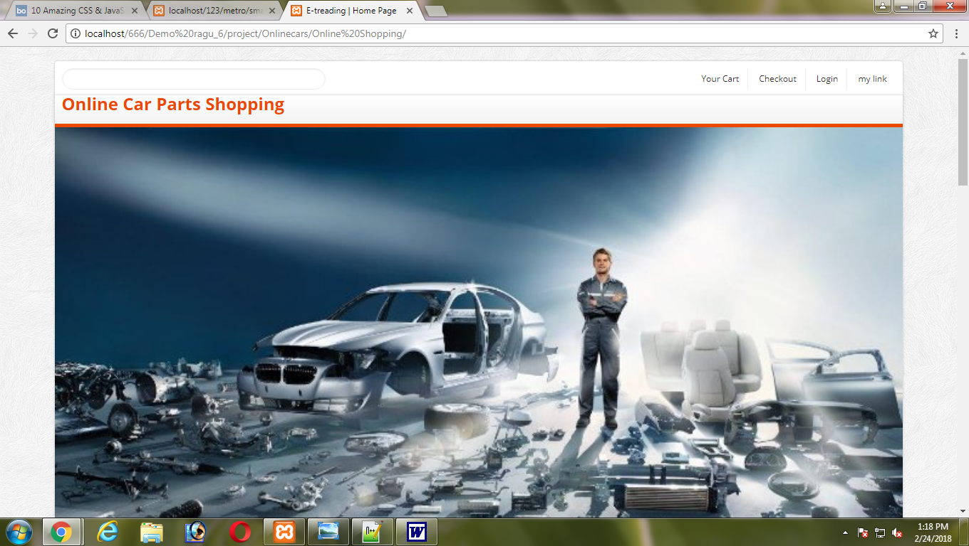

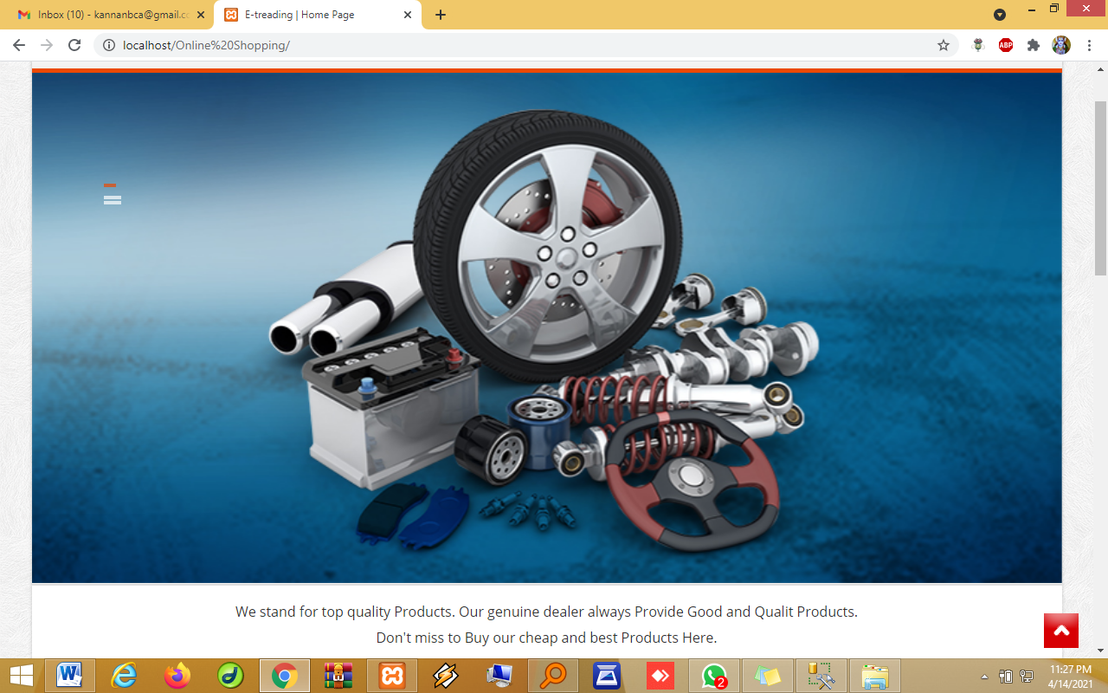

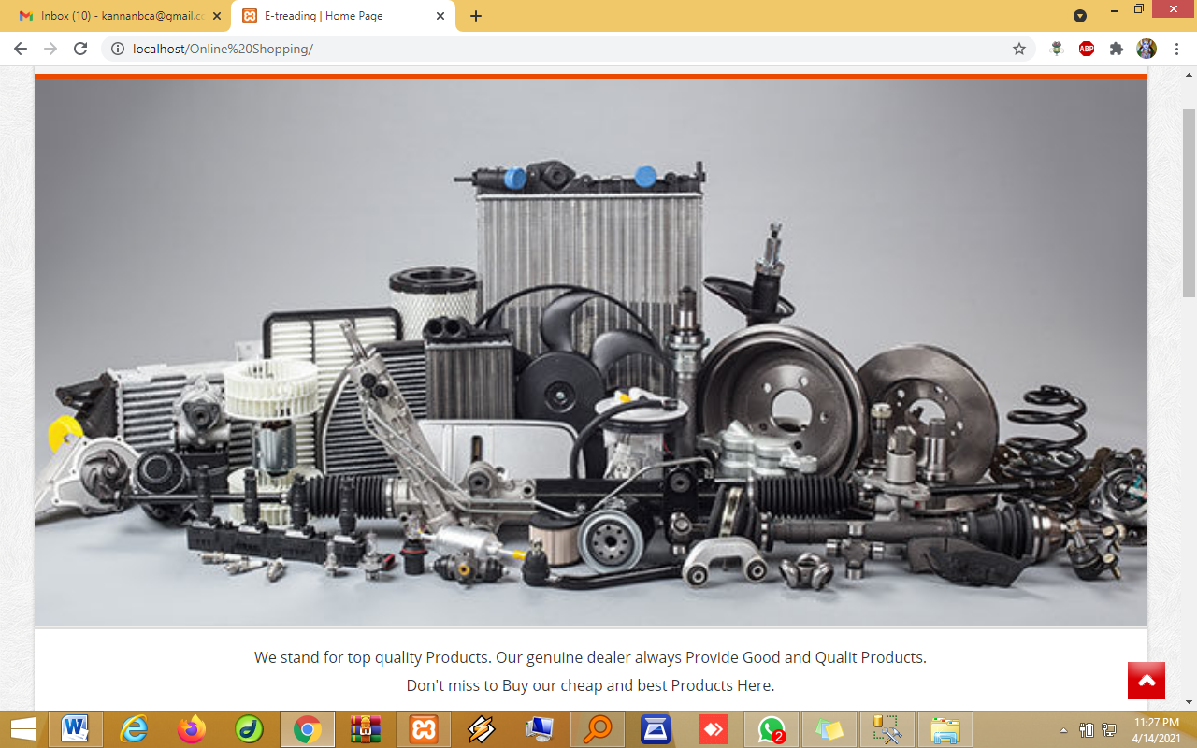

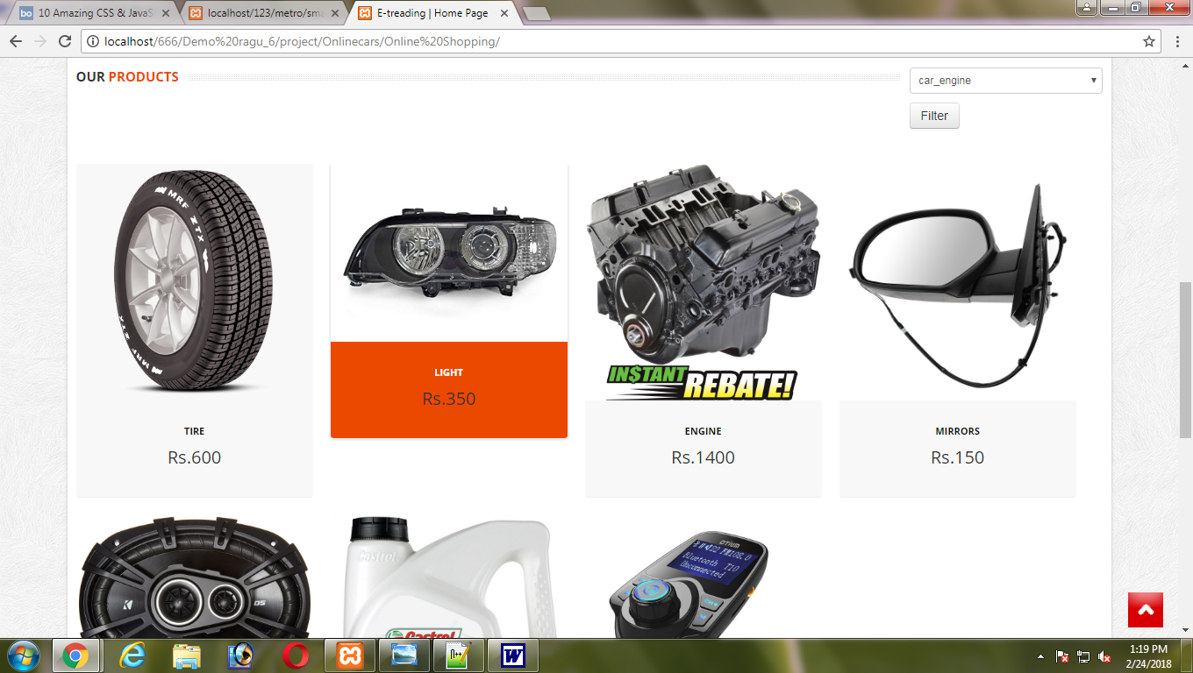

Add card:

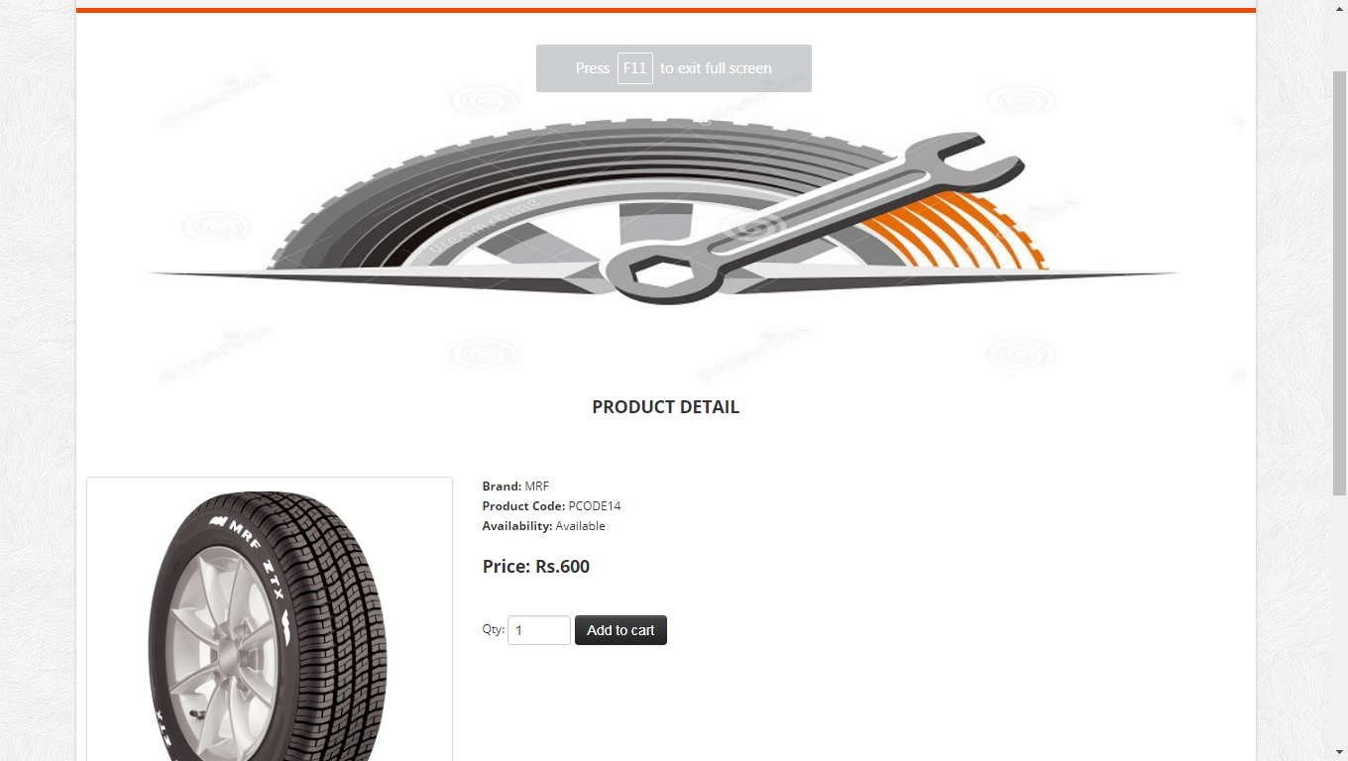

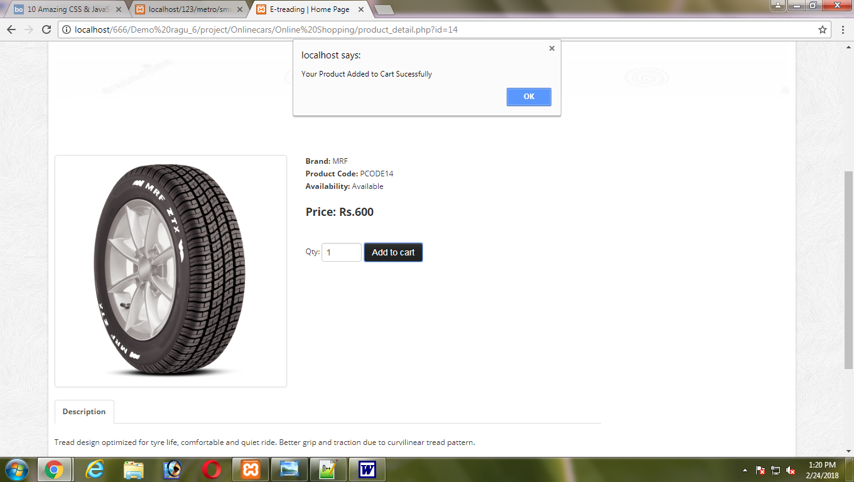

Shopping card:

